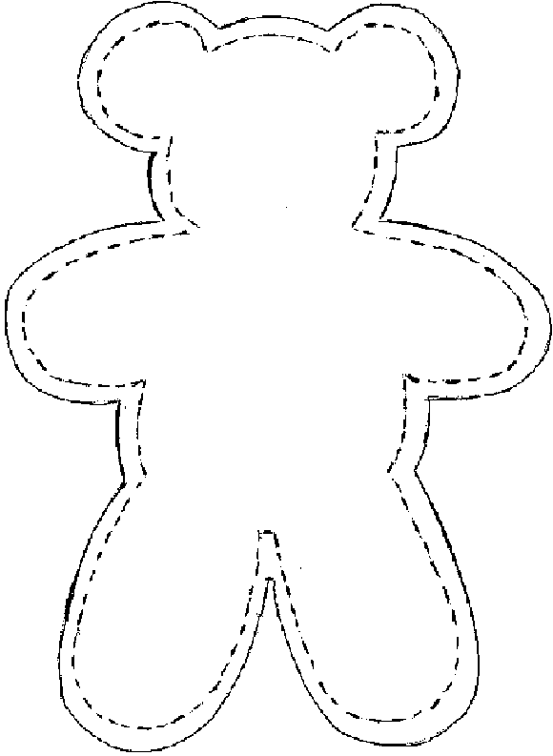

A **BEAR HUG** is a stuffed raw edged sewn bear made with 2 pieces of fleece. With a raw edged appliqued heart on its chest.

If donating with a quilt, it is suggested the heart be made of one fabric from the quilt.

The **BEAR HUG** is a friend that a child can tell all his/her secrets to as he/she is snuggling under their quilt.

The BEAR HUGS are just a little extra that can be easily made and added to quilt donations to children.

Raw edge applique heart here!